Structure and Optical properties of Lead Sulfide (PbS) Thin Film Prepared by Chemical Bath Deposition(CBD) Technique: A Review
Ghazwan Ghazi Ali^{1*}, Tahseen Ali Aswad²
^{1*}Physics Department, College of Education for Pure Science, Mosul University, Iraq
²The Directorate General of Education in Salah al Din, Iraq

ARTICLE INFO |  |  | ABSTRACT
Received: 13 / 08 /2023  Accepted: 05 / 11 / 2023  Available online: 00 / 12 / 2023  DOI: 000000000000000000000 |  |  | In this review, the chemical bath deposition method has been studied to investigate lead sulfide thin film. The important results obtained from XRD, AFM and optical Spectrophotometer measurements were discussed. peaks patterns illustrated that the lead sulfide structure have a cubic phase nanocrystalline corresponded to the strong peaks (111) and (200) at 2θ ≅ 26.3◦ and 29.8◦ respectively. Atomic force microscope (AFM) images exhibited that the lead sulfide (PbS) thin films have a nano-size grain also the grain size increased with increasing film thickness. Different parameters such as dislocation density and internal strain have been studied to be decreased with concentration. Decreasing internal strain and dislocation density with increasing concentration show enhancement of lattice constant as prepared films Scanning electron Microscope (SEM) images displayed that the top surface layers are strongly affected depending on the nature top. The PbS structure are quite homogeneous , the size distribution was about 71–83 nm. The influence of deposition time, thickness, nature of the substrate, concentration of solution and doping on the PbS films was also discussed. It can be seen, The prepared thin film was a thinner film with a short deposition time compared to prepared samples with a longer time. It has also been found that the precipitated films show optical absorbance in the room and UV region but their absorbance decreases upon entering the near-infrared (NIR) region. Lead Sulfide thin films have gained remarkable attention worldwide due to an important narrow band gap semiconductor which has broad potential applications in optoelectronics devices.  .
Keywords:
Thin Film; Chemical Bath Deposition; Lead Sulfide; Structural and Optical Properties.
Copyright©Authors,, 2022, College of Sciences, University of Anbar. This is an open-access article under the CC BY 4.0 license (http://creativecommons.org/licens es/by/4.0/).

Introduction:
Nowadays, many researchers have been interested in semiconductors (IV-VI) for use in photovoltaic devices. Lead sulfide nanostructure was the one of it most promising alternative materials due to its unique [1,2]. Lead sulfide is unique promise material (p-type) characterized by a direct, narrow energy gap, very high carrier mobility, large Bore radius, higher constant dielectric, and very important absorbnce coefficient [3,4,5]. Additionally the size of nanostructure lead sulfide (PbS) reached less than the radius of Bohr quantum effects of electrons and holes occurred, this quantum effect leads to the creation of separate electronic states in the (CB) and (VB) of the hetrostructure compared with the density state of surface in the volumetric substance [6,7].

*Corresponding author at: Physics Department, College of Education for Pure Science, Mosul University, Iraq;
ORCID:https://orcid.org/0000-0000-0000-0000;Tel:+964000000000000
E-mail address: dr.ghazwan39@uomosul.edu.iq

Lead sulfide (PbS) thin film has several practical applications such as infrared detectors [8,9,10], transistors, solar cells and biosensors [11,12,13] solar absorbers[14], photographs[15], telecommunications[16], LED devices[17], photonic switches [18,19] diode lasers [20,21] temperature and humidity sensors and coatings decorative, solar control [22,23,24] and quantum dot applications. Lead sulfide (PbS) thin film can be prepared in several ways such as successive ion layer absorbance[25], chemical deposition [26], spray method [27], galvanic method [28] atomic layer deposition [29] pulsed electro-deposition [30,31] vacuum evaporation [32] chemical vapor deposition [33,34] pulsed laser ablation [35] molecular beam filling [36] and microwave heating [37] in addition to the gelatin method [38]. Chemical Deposition has been widely useful for deposition because the technique is considered one of the most advantageous methods such as lower working temperatures, lower cost and easy deals of large size compared to other chemical methods. CBS technology also provides another advantage, which is the possibility of depositing films in different shapes, types and sizes of bases [39]. The aim of this review is to study the peaks patrrens (XRD), surface (SEM &AFM) and (UV- spectrophotometer) of PbS thin films at various concentration.

Experimental method
The chemical bath method requires controlling the concentrated solution on the appropriate substrate. This technique provides many benefits compared to other deposition methods such as chemical deposition. It can be seen to control the thickness of the film. Glass substrates (2.2 x 2.2 cm) were used. All samples are immersed inside the water and keep in an ultrasonic sample for 8 minutes. The stirrer of acetate solution was for 40 min at temperature room after that the keep was heating up to 85º C for one hour by magnetic stirrer. It can be seen to control the thickness rate by changing the pH function, temperature, deposition time, and the concentrations of the reactants. One of the most important advantages of this technique is compatible with the possibility of deposition over large areas at a low cost. Figure 1 shows the chemical bath deposition technique.

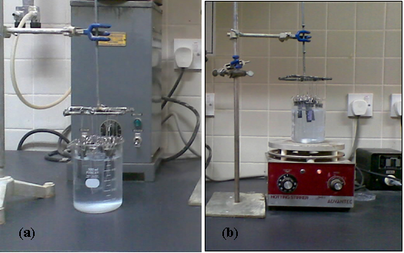
Figure 1: photograph of Chemical method at the surface (a) at room temperature ,(b) at 80 ºC [40].

Results and Discussion
Structure properties
Structure properties were used to determine molecular thin film structure of Pb in different M. This Figure 2 shows a diagram of X-ray diffraction at a concentration of 0.15M. The results show many papers explained that the prepared substrate has a face-centred cubic structure with direction (200) with a hexagonal structure [41]. Many researchers have been used the chemical method to study lead sulfide (PbS) for example (Seghaier et al., 2006 and Abass et al., 2009). They prepared of lead sulfide (PbS) and silicon by the method surface chemical. It was found that the substrate has a cubic phase and a preferred direction in the (200) axis, Furthermore. The (XRD) spectra exhibit it is no clear stress for the substrates. The formed particle size was found between 26-46 nm, and the deposition time changes from 15 to 130 minutes. The particle size increases with increasing thickness depending on the growth conditions. The results show that the great adhesion and better crystallization of (PbS) lead sulfide of the substrate glass were observed using 0.5 M of sodium , 0.15 M of lead nitrate and 0.1 M of thiourea for a deposition time about 70 minutes. The influence of the time of the deposition of the surface thickness was exhibited in Figure 3 b , it was found that the surface film increased with increasing deposition time. The influence of the concentration of each sodium hydroxide, lead nitrate and thiourea was studied separately on the film thickness as in Figures 3(a, c and d), It was observed the film thickness decreases at high concentrations. These results are agreement with previous research [42].
Figure 2: X-ray of PbS film at a concentration of 0.15M

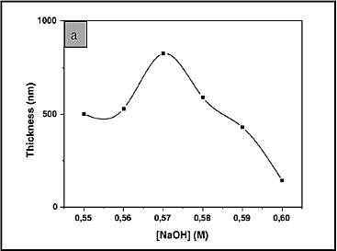
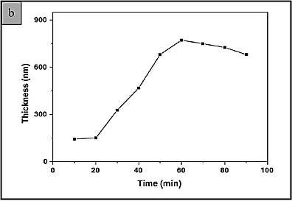
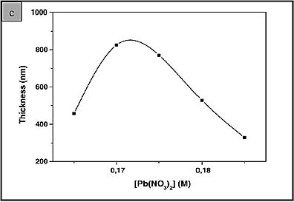
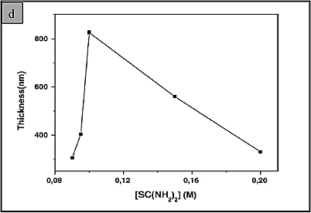
Figure 3: Film thickness (PbS) as a surface of (a) NaOH concentration, (b) deposition time, (c) lead nitrate concentration, (d) thiourea concentration

Figure 4 (a, b, c and d) illustrated the preparation and fabrication of the films lead sulfide structre doped with Nickel (PbS: Ni) in different ratios by deposition bath structure at the surface morpholoy. Structural characteristics of the deposited films were noted that the crystal structure, it is obvious that the dimeter for the crystals increased by the increasing the molarity as shown in Figure 4. These results are agreement with previous research (Obaid et al., 2012). Many structural parameters such as internal stress, dislocation density, etc., were observed and calculated to decrease in of both films (pure and deposited film) have cubic, it has been verified that the size particle of doped film (PbS: Ni) was smaller than the size particle of the pure film (PbS) using the obtained (XRD) patterns, due to the PbS: Ni thin film has a granular size. The X-ray resulting of (XRD) show that the PbS: Ni surface has nature molarity. It was also seen that the lattice constant structure shifts from the volumetric const. of the lattice constant (5.987 ºA), this change in the fabricated films indicates stress. The dislocation density with an increase in molarity improved the structure of the films lattice [43].
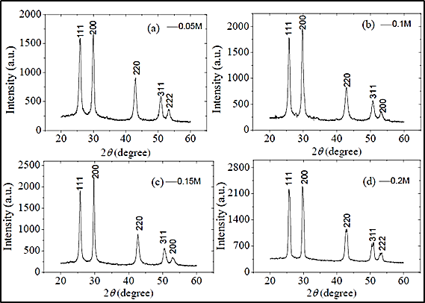
Figure 4: patrren diffraction (XRD) of PbS at various concentrations.
Figure 5 shows the preparation of lead sulfide (PbS) nanoparticles by (CBD) and exhibited the influnce of the thickness of the substrate by using the time constant, Furthermore, (Palomino et al., 2013) concluded the thickness also increases with the time constant. The resulting of the XRD pattern illustrated that the lead sulfide (PbS) sample has a face-centred cubic symmetry, a lattice constant was 5.9345 Å and a crystal size of 55.54 nm [44]. Furthermore, lead sulfide (PbS) nanocrystalline film has prepared by (CBD) in microwave oven the system at a temperature of 80 degrees Celsius and for different periods (30, 60,90 and 120) minutes and different concentrations by (Göde et al., 2015). The deposited films contain of grains, and the size of these grains increases with thickness. Moreover, the film thickness increased by an increased time deposition, these results are in agreement with [ 45, 46].
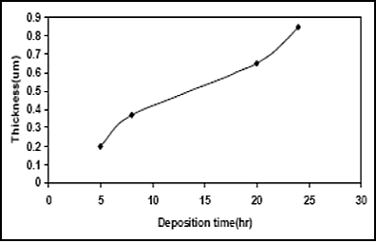
Figure 5: Change of film thickness (PbS) with deposition time.

Surface properties
Scanning Electron microscope
Figure 6 desipts SEM photographs of tin sulfide film doped with mercury ions (Hg⁺²), we note that the grain size areformed in clusters and the size increases with the increasing doping rate. This resulting is in agreement by (Rajathi et al., 2017) who was prepared the lead sulfide thin films (PbS) doped with mercury ions (Hg ²) with a nanocrystalline structure using chemical bath deposition (CBD) [47].
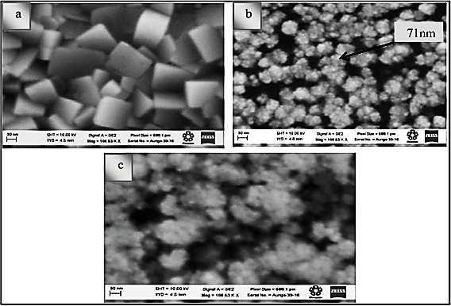
Figure 6: SEM images of PbS films: (a) pure Pb (b,c) dropsied with Hg.

Atomic Force microscope
Atomic Force microscope
Figure 7 shows (AFM) images, the results show the prepared films have nanostructures with a film of 100 nm and the diameter size of 62 nm. The surface structure of the film (Roughness) increases with the increase thickness of the film. In other words, the films have a good arrangements and good homogeneous to the bottom layer by a point surface of the dark. The average thickness was found 2 µm, and all the deposited films showed stable behavior. lead sulfide thin films (PbS) have been produced at room temperature on a surface substrate for two hours by deposition bath of chemical by (Abdallah et al., 2018) [48]. Additionally, (Horoz et al., 2018) studied the nano-thin films of lead sulfide (PbS) and others doped with cadmium (Cd-PbS) at 80 ºC by the chemical bath deposition method. It can be seen the particle size increased from 1.8 µm to 2.5 µm after annealing. The pure films and doped cadmium showed good crystallization and adhesion on the substrate. The films have good roughness and surface homogeneity. Furthermore, the diameter size decreased from 74 to 64 nm with an increaseing doping rate, these results are in agreement with [49].
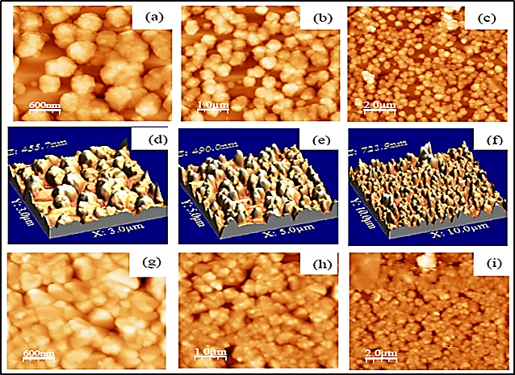
Figure 7: Atomic force microscope images of lead sulfide (PbS) films doped with cadmium (Cd-PbS) on glass substrate.
Optical properties
Figure 8 shows the study of lead sulfide deposited on aluminium by the deposition bath of chemical sample by (Manouchehri et al.,2018). It was found that the film of substrate thickness varies based upon the nature of the substrate, the fixed parameters structural like crystal pore, internal pressure, constant lattice and optical properties of composite (PbS) have also been affected using the chemical nature of the substrate It was observed from the UV spectrum that the Absorbance edge changed with the lower wavelength in the deposited films.
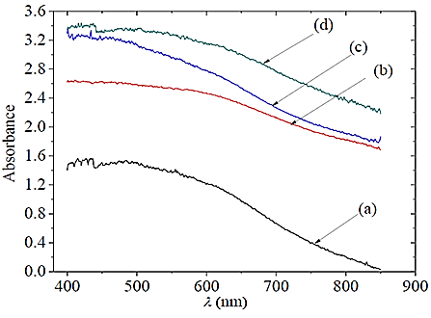
Figure 8: Absorbance with wavelength of PbS lead sulfide film deposited on aluminum and glass (a) Pb thin film deposited on aluminum(0.05M) and Pb deposited on glass at concentration (b) 0.1M, (c) 0.15M and (d) 0.2 M.

The optical properties show that lead sulfide structure depoted on aluminium at the substrate glass of concentration (0.05M) is more transparent than the film on the glass substrate of (0.2M) due to effect on the morphological properties of the deposited substrate , these results are in agreement with [27, 50,51]. It can be seen the improvement of the physics properties of thin films via choosing the appropriate substrate. It is obvious that film surface size increased with increased deposition time, and the value of the energy gap increased (1.59 - 1.65) eV with the increase in the deposition time, as shown in Figure (9 a, b).
The properties of high reflectivity also higher absorption in the UV structure and also high reflectivity and low absorption in the infrared (IR) region produce a good film for sensors, solar thermal applications, and anti-reflective coatings. In brief, the film thickness increases when the energy gap decreased leading to the increased of the coefficient of the absorption for the prepared films as shown in Figure (10a,b).
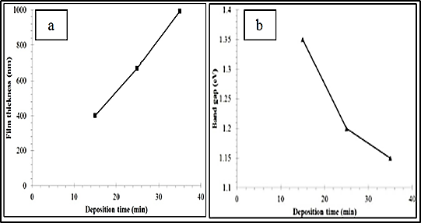
Figure 9: (a) Thickness & deposition time , (b) Band gap & deposition time
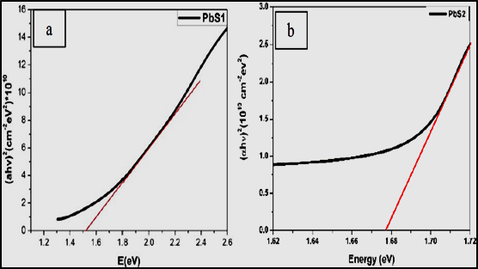
Figure 10: (αh(טּ² ageist gap energy Eg(eV) at concentration (a) 0.1M, (b) 0.2M concentration.

Conclusion
Lead sulfide (PbS) have been studied by the (CBD) method, which is a low-cost and simple method. The obtained films were studied and analyzed using (XRD), morphology (SEM& AFM) and optical properties (UV-VIS). The simmered results including, the deposited films are the structure of nano-polycrystalline in nature and grown in the form of a cubic crystalline structure with two preferred orientations (111) and (200). Furthermore, deposition time increases by the increased the thickness of the film, this leads to a decrease in the energy gap and then an increased for all the absorption coefficients, the roughness surface, and the grain size. additionally, increasing the concentration rate leads to a decline in the lattice constant and gap energy and a rise in the particle size. Furthermore, increasing of the doping due to an increased in both the gap energy and the activation energy. The particle sizes increase with increasing annealing temperature. Finally, lattice constant, crystal size, internal stress, and UV properties of the prepared thin films are the influence by the chemical nature of the substrate on which they are deposited.

Acknowledgement
We are thankful and gratitude to the, department of Physics, University of Mosul, and the Directorate General of Education in Salah al-Din for providing all the required facilities.

References
[1] Duan, T., Lou,W., Wang, X. and Xue, Q. (2007). ″Size-controlled synthesis of orderly organized cube-shaped lead sulfide nanocrystals via a solvothermal single source precursor method″, Colloids and Surfaces A: Physicochemical and Engineering Aspects, 310, 86-93.
[2]Mitesh, H. P. , Tapas, K. C. , Vaibhav, K. P. (2017). Shripathi, T. , Deshpande, U. & Lalla, N. P , Dip-coated PbS/PVP nanocomposite films with tunable band gap, RSC Adv., 63(7) 4422-4429.
[3] Defa, W., Jayanta, K. B. , Haiguang, Z. , Belete, A. G., Vo-Van, T., My Ali, E. K., Ricardo, I. & Dongling, M. (2011). Controlled fabrication of PbS quantum-dot /carbon nanotube nanoarchitecture and its significant contribution to near infrared photon-to-current conversion, Adv. Funct. Mater., 21, 4010–4018.
[4] Bai, R. , Kumar, D. , Chaudhary, S. & Pandya, D. K. (2017). Highly crystalline p- PbS thin flms with tunable optical and hole transport parameters by chemical bath deposition, Acta Mater.,131, 11-21.
[5] Moreno, O. P. , Lima, L. A. C. , Portillo, M. C. , Castilla, S. R. , Tototzintle, M. Z. , Avila, G. A. & Perez, R. G. (2012). Properties of PbS:Ni²⁺ nanocrystals in thin flms by chemical bath deposition, ISRN Nanotechnol.,1–13 DOI: 10.5402/2012/546027.
[6] Ahmed, A. M. , Rabia, M. & Shaban, M. (2020). The structure and photoelectro- chemical activity of Cr-doped PbS thin films grown by chemical bath deposition. The Royal Society of Chemistry, 10(24), 14458–14470.
[7]Hern´andez-Borja, J., Vorobiev, Y. V. & Ram´ırez-Bon, R. (2011). Thin film solar cells of CdS/PbS chemically deposited by an ammonia-free process. Solar Energy Materials and Solar Cells, 95, (7) 1882-1888.
[8]Ghamsari, M. S. , Araghi, M. K. & Farahani, S. J.(2006). The influence of hydrazine hydrate on the photoconductivity of PbS thin film. Materials Science and Engineering: B, 133, (1-3), 113–116.
[9]Gunes, S. , Fritz, K. P. , Neugebauer, H. , Sariciftci, N. S. , Kumar, S. & Scholes, G. D. (2007). Hybrid solar cells using PbS nanoparticles. Solar Energy Materials and Solar Cells, 91,(5) 420-423.
[10]Enue, B., Rodrguez, Y., Juan, P. P., Colin, J., Altuzar, P., Campos, J. & David, Q. (2019). Effect of Deposition Time on the Optoelectronics Properties of PbS Thin Films Obtained by Microwave-Assisted Chemical Bath Deposition. Advances in Condensed Matter Physics, 8 pages, DOI: 10.1155/2019/5960587.
[11]Abdallah, B. , Hussein, R. , Al-Kafri, N. & Zetoun, W. (2019). PbS Thin Films Prepared by Chemical Bath Deposition:Effects of Concentration on the Morphology, Structure and Optical Properties. Iranian Journal of Science and Technology, Transactions A: Science, 43, pages1371–1380.
[12]Ho Soonmin, A. K. & Tan, W. (2014). Chemical Bath Deposited Lead Sulphide Thin Films: Preparation and Characterization. World of Mechanics,1 (1), 1-6.
[13]Tusamalee, P., Buranasiri, P., Chaisitsak, S. & Yindeesuk, W. (2017). Optical Properties of PbS Thin Films Prepared by Successive Ionic Layer Adsorption and Reaction Processes. Journal of Materials Science and Applied Energy, 6(3), 211- 214.
[14]Aadim, K. A. Ibrahim, A. E. & Marie, J. M. (2017). Structural and Optical Properties of PbS Thin Films Deposited by Pulsed Laser Deposited (PLD) Technique at Different Annealing Temperature. International Journal of Physics, 5(1), 1-8.
[15]Ubale, A.U. , Junchara, A.R. , Wadibhasme, N.H. , Darya Purkab, A.S. , Mankar, R.B. & Sangawar, V.S. (2007). Thickness dependent structural, electrical and optical properties of chemically deposited nano particle PbS thin film, Turk. J. Phys, 31, 279-286.
[16]Kumar, R. & Das, R. (2014). Optical and Electrical Characterization of Nano- crystalline (Pb_{1- X}bi) S Thin Films Deposited at Room Temprature. IOSR Journal of Applied Physics, e-ISSN: 2278-4861, PP 07-10.
[17]Nascu, C. , Vomir, V. , Pop, I. , Ionescu, V. & Grecu, R. (1996). The study of lead sulphide films.VI. Influence of oxidants on the chemically deposited PbS thin films , Mater. Sci. Eng. B. 841, 235-240.
[18]Machol, J.L. , Wise, F.W. , Patel, R.C. & Tanner, D.B. (1993). Vibronic quantum beats in PbS microcrystallites Phys. Rev. B., 48, 2819- 2822.
[19]Nayak, B.B. & Acharya, H.N. (1985). Characterization of chemically deposited Pb1-x CdxS films by scanning electron microscopy, J. Mater. Sci. Lett.4, 651-652.
[20]Thangaraju, B. & Kaliannan, P. (2000). Polycrystalline lead tin chalcogenide thin film grown by spray pyrolysis, Cryst. Res. Technol. 35(1), 71-75.
[21]Nair, P.K. , Garcia, V. M. , Hernandez, A.B. & Nair, M.T.S.(1991). Photoacceler-ated chemical deposition of PbS thin films: novel applications in decorative coat-ings and imaging techniques. J. Phys. D: Appl. Phys. 24, 1466-1472.
[22]Pop, I. , Nascu, C. , Ionescu, V. , Indrea, E. & Bratu, I. (1997). Structural and optical properties of PbS thin films obtained by chemical deposition, Thin Solid Films 307, 240–244.
[23]Malyarevich, A. M. , Gaponenko, M. S. , Savitski, V. G. , Yumashev, K. V. , Rachkovskaya, G. E. & Zakharevich, G. B. (2007). Nonlinear optical properties of PbS quantum dots in borosilicate glass, Journal of Non-Crystalline Solids, 353, (11-12), 1195–1200.
[24] Ezekoye, B. A. , Emeakaroha, T. M. , Ezekoye, V. A. , Ighodalo, K. O. & Offor, P. O. (2015). Optical and structural properties of lead sulfide (PbS) thin films synthesized by chemical method. International Journal of Physical Sciences,10 (13), 385-390.
[25] Gülen, Y. (2014). Characteristics of Ba-Doped PbS Thin Films Prepared by the SILAR Method. Acta Physica Polonica A. 126, 763-767.
[26] Puišo, J. , Lindroos, S. , Tamulevicius, S. , Leskelä, M, , Snitka, V. (2003).The influence of the pretreatment of Si substrate on the growth of PbS thin films in the SILAR Technique. Solid State Phenomena, 94, 261- 264.
[27] Sarma, M.P. & Wary, G. (2017). Effect of Molarity on Structural and Optical Properties of Chemically Deposited Nanocrystalline PbS Thin Film. Internation- al Letters of Chemistry, Physics and Astronomy, 74, 22-35.
[28] Thangaraju, B. , Kalainnan, P. (2000). Spray pyrolytically deposited PbS thin films, Semicond. Sci. Technol. 15 , 849–853.
[29] Mondal, A. , Mukherjee, N. (2006). Cubic PbS thin films on TCO glass substrate by galvanic technique. Mater Lett, 60, 2672-2674.
[30]Sharon, M. , Ramaiah, K.S. , kumar, M. , Neumann-Spallart, M. & Levy Clement, C. (1997). Electrodeposition of lead sulphide in acidic medium,Journal of Electroanalytical Chemistry. 436 (1-2), 49-52.
[31]Ge, J. P. , Wang, J. , Zhang, H. X. , Wang, X. , Peng, Q. & Li, Y. D. (2005). Orthogonal PbS nanowire arrays and networks and their raman scattering behavior, Chrmistry A European Journal, 11,(6) 1889-1894.
[32]Dawood, Y. Z. , Kadhim, S. M. & Mohammed, A. Z. (2015). Structure and optical properties of nano PbS thin film deposited by pulse laser deposition, Eng & Tech Journal,. Part (B), 32, 1723–1730.
[33]Koao, L. F. , Hone, F. G. & Dejene, F. B. (2020). Synthesis and characterization of PbS nanowires doped with Tb³⁺ions by using chemical bath deposition method. Journal of Nanostructure in Chemistry, 10,1–7.
[34]Saraidarov, T. , Reisfed, R. , Sashchiuk, A. , Lifshitz, E. (2005). Nanocrystallites
of lead sulfide in hybrid films prepared by sol-gel process. J. Sol-Gel Sci.Technol. 34, 137–145.
[35]Oriaku, C.I. & Osuwa, J.C. (2008). Analysis of thin chalcogenide PbS films prepared from chemical path, The Specific Journals of science and technology, 9 (2), 461-467.
[36]Busarin, N. , Panita, C. ,Intira, S. & Chanwit, C. (2008). The Influence of Growth Conditions on the Chemical Bath Deposited ZnS Thin Films. Journal of Metals, Materials and Minerals, 18 (2 ) , 49-52.
[37]Cheemadan, S. , Keerthana, K. & Santhosh Kumar, M. C. (2013). Analysis of Structural and Electrical Properties of Aluminium Doped Lead Sulphide (PbS) Thin Films Prepared by CBD Method. J. Environ. Nanotechnol., 2(4), 28-33.
[38]Olabisi, O. & Adegboyega, O., (2018). Optical and Microstructural Analysis of Chemically prepared Lead Sulphide (PbS) Thin Film. International Journal of Trend in Scientific Research and Development, 2(2), 1006-1008.
[39]Kavitha, C. , Gopinathan, C. & Pandi, P. (2017). Lead Sulfide (PbS) Thin Film with Different Thiourea Concentrations. Journal of Nanoscience and Technology , 3(3), 284–288.
[40]Ramalan, A.M. , Yusuf, A.S. , Samson, D.O. & Buba, A.D. (2018). Optical, Morphological and Electrical Properties of PBS Thin Films Prepared by Chemical Bath Deposition (CBD) Technique at Different Deposition Time. American Based Research Journal, 7(11), 1-8.
[41]Raghumani, S. L. , Nabachandra, S. A. , Nabadwip, S. S. & Bidyaswor, S. S., (2018). Structural Characterization of PbS and Cd-doped PbS Nanocrystalline Thin Film Fabricated By Chemical Bath Deposition Technique. International Journal of Innovative Research in Science, Engineering and Technology,7(1), 537-541.
[42]Seghaier, S. , Kamoun, N. , Brini, R. & Amara, A.B. (2006). Structural and optical properties of PbS thin films deposited by chemical bath deposition. Materials Chemistry and Physics, 97, 71–80.
[43]Abass, M., Al-Fawadi, E.& Al-Samuraee, A. K.(2009). Preparation of Nanocry-stalline PbS Thin Films by Chemical Bath Deposition. Materials Science and Technology, October 25-29 , 2637-2646.
[44]Obaid, A.S. , Mahdi, M. A. , Dihe, A. A. & Hassan, Z. (2012). Effect of Depositi- on Time on the PbS Thin films Prepared using Microwave-Assisted Chemical Bath Deposition: Structure and Optical Characterization. International Conference on Education, Applied Sciences and Management, December 26-27, 86-89.
[45]Palomino, M. R. , Portillo, M. O. , Chaltel, L. A. , Gutiérrez, P. R. , Icaza, H. M. & Castaño, V. M. (2013). Chemical Bath Deposition of PbS:Hg²⁺ Nanocrysta- lline Thin Films. Journal of Nanomaterials, Research Article, 6 pages.
[46]Göde, F. , Yavuz, F. and Kariper, I.A. ″Preparation and Characterization of Nanocrystalline PbS Thin Films Produced by Chemical Bath Deposition″. Acta Physica Polonica A, 128,2, 215-218, (2015).
[47]Aye, M. M. , Win, H. H. & Aung, M. T. (2017). Nanocrystalline lead sulphide thin films fabrication and characterization. International Research Journal of Advanced Engineering and Science, 2(3), 257-260.
[48]Rajathi, S. , Kirubavathi, K. & Selvaraju, K. (2017). Preparation of nanocrystal- line Cd-doped PbS thin films and their structural and optical properties. Journal of Taibah University for Science, 11, 1296–1305.
[49]Abdallah, B. , Ismail, A. , Kashoua, H. & Zetoun, W. (2018). Effects of Deposition Time on the Morphology, Structure, and Optical Properties of PbS Thin Films Prepared by Chemical Bath Deposition. Journal of Nanomaterials, Research Article, 8 pages.
[50]Horoz, S. , Ekinci, A. & Sahin, O. (2018). Synthesis of PbS and Ni-doped PbS thin films by CBD method and investigation of their structural, optical and photovoltaic properties. Journal of Ovonic Research, 14(3), 201 – 208.
[51]Manouchehri, S. , Zahmatkesh, J. & Yousefi, M. H. (2018). Substrate Effects on the Structural Properties of Thin Films of Lead Sulfide. Journal of Optoelectron- ical Nanostructures, 3(2), 1-18.

الخصائص التركيبية والبصرية لغشاء كبريتيد الرصاص (PbS) المحضر بتقنية الترسيب الحمام الكيميائي: مراجعة مقالة

غزوان غازي على^{1*} , تحسين علي أسود²
^{1*}كلية التربية للعلوم الصرفة , قسم الفيزياء, جامعة الموصل , العراق
²المديرية العامة لتربية صلاح الدين , العراق
dr.ghazwan39@uomosul.edu.iq , tahseenphysics84@gmail.com

الخلاصة:
في هذه المقالة، تم دراسة الأغشية الرقيقة لكبريتيد الرصاص (PbS) بطريقة الترسيب بالحمام الكيميائي (CBD). تم مناقشة النتائج المهمة التي تم الحصول عليها من قياسات حيود الأشعة السينية(XRD)، المجهر الالكتروني الماسح (SEM)، مجهر القوة الذرية (AFM)، مطياف الأشعة فوق البنفسجية-المرئية (UV-VIS). بينت انماط حيود الاشعة السينية بان اغشية كبرتيد الرصاص تمتلك تركيب بلوري نانوي ذو طور مكعب مطابقة مع اعلى القمم (111) و(200) عند زوايا الحيود 2θ ≅ 26.3◦ , 29.8◦, حيث أظهرت صور مجهر القوة الذرية (AFM) بان الأغشية الرقيقة لكبريتيد الرصاص(PbS) تتكون من حجوم حبيبات نانوية ويزداد حجم هذه الحبيبات مع زيادة سمك الغشاء. تم دراسة العديد من المعلمات الهيكلية مثل الإجهاد الداخلي وكثافة الخلع ولوحظ انها تقل مع زيادة المولارية أذ يشير تقليل الإجهاد الداخلي وكثافة الخلع مع زيادة المولارية إلى تحسن خواص الشبيكة للأغشية المحضرة. وضحت صور المجهر الالكتروني الماسح (SEM) بان طبقات السطح العليا تتأثر بقوة بطبيعة القاعدة وان غشاء PbS متجانس تماما ووجد ان حجم التوزيع كان بحدود (71-83nm), كما لوحظ أن الأغشية المحضرة باستخدام وقت ترسيب اقصر كانت أرق من تلك التي تم تحضيرها بوقت أطول. تم مناقشة تأثير زمن الترسيب، سمك الغشاء، طبيعة القاعدة، تركيز المحلول والتطعيم بمواد مختلفة على خواص أغشية كبريتيد الرصاص. وقد وجد أيضاﹰ أن الأغشية المترسبة تظهر امتصاصاﹰ ضوئياﹰ قوياﹰ في المنطقة المرئية ومنطقة الأشعة فوق البنفسجية ولكن امتصاصها ينخفض عند دخولها منطقة الأشعة تحت الحمراء القريبة (NIR) من الطيف الكهرومغناطيسي. جذبت الأغشية الرقيقة لكبريتيد الرصاص اهتمامًا ملحوظًا في جميع أنحاء العالم بسبب احتوائها على فجوة نطاق ضيقة والتي لها تطبيقات محتملة واسعة في نبائط الإلكترونيات الضوئية لأشباه الموصلات(PbS).

الكلمات المفتاحية: غشاء رقيق، الترسيب بالحمام الكيميائي، كبريتيد الرصاص، الخصائص التركيبية والبصرية.

