Modification of polyvinyl chloride by organic molecule for the improvement of its thermal stability
Zahraa N. Adnan¹, Ahmed A. Ahmed¹, Dina Ahmed², Alaa A Rashad¹, Mohammed Kadhom^{3*}, Amamer M. Redwan⁴, Waled Abdo Ahmed⁵, Emad Yousif^{1,}
¹ Department of Chemistry, College of Science, Al-Nahrain University, Baghdad, 10070, Iraq
² Department of Chemical Industries, Institute of Technology-Baghdad, Middle Technical University, Baghdad, Iraq
³ Department of Environmental Science, College of Energy and Environmental Sciences, Alkarkh University of Science, Baghdad, 10081, Iraq
⁴ Department of Chemistry, Faculty of Science, Bani Waleed University, Bani Waleed, Libya
⁵ Department of Chemistry, Faculty of Education, Thamar University, Dhamar 87246, Yemen
ARTICLE INFO |  |  | ABSTRACT
Received: 00 / 00 /2023  Accepted: 30 / 10 / 2023  Available online: 00 / 00 / 2023  DOI: 000000000000000000000 |  |  | Improving the stability of PVC became a task for many research groups to improve its properties and lower plastic pollution. An invented Schiff base was applied as a heat-resistant agent to alter polyvinyl chloride (PVC) behavior under varying temperatures. The efficacy of the Schiff base-treated PVC films in terms of thermal stability was assessed through weight-loss analysis, Fourier transform infrared (FTIR) spectroscopy, an optical microscope, and atomic force microscopy (AFM). The outcomes demonstrated that incorporating the altered PVC extended the polymer's stability duration, consequently lowering its inclination towards degradation. Furthermore, the Schiff base led to a marked decrease in the presence of PVC's conjugated double bonds, consequently reducing weight loss. The enhancement observed can be credited to the Schiff base's strong ability to neutralize HCl and its effectiveness in protecting unstable chlorine atoms within the polymer chains. These alterations, when combined, resulted in a prolonged delay in thermal degradation and alterations in color, affirming the success of the modification method in improving the thermal stability of PVC.  .
Keywords:
polyvinyl chloride (PVC); morphology; thermal stability; modification; Schiff base
.
Copyright©Authors, 2022, College of Sciences, University of Anbar. This is an open-access article under the CC BY 4.0 license (http://creativecommons.org/licens es/by/4.0/).

Introduction
Polymers play a crucial and unavoidable role in various aspects of human activities [1]. The choice between using virgin polymers, polymer blends, or polymeric composites depends on specific needs. To modify the properties of these polymers as required, reinforcement fillers can be incorporated, or structural and functional group modifications can be applied. In fact, numerous studies in the literature address these subjects [2]. Different types of polymer composites can be created based on the chosen reinforcement, including micro composites, nanocomposites, and fiber-filled composites.
*Corresponding author at: Department of Chemistry, College of Science, Al-Nahrain University, Baghdad, 10070, Iraq
ORCID: 0000-0003-1458-4724
E-mail address: emadyousif@hotmail.com

Nanocomposites involve combining materials of distinct natures, with at least one of them being on the nanometer scale (≤ 100 nm). Recent years have seen an affluence of abundance research on polymer nanocomposites, encompassing everyday and specialized plastics, leading to the development of various valuable products. A substantial body of literature is now accessible concerning these materials [3,4]. Understanding of PVC's behavior at elevated temperatures is especially crucial due to its significance as a primary source of chlorine. Extensive research on the thermal degradation of PVC dates back to the 1960s, with Braun et al. playing a significant role [5]. Pioneering work by Wakeman and Johnson detected gaseous species like aromatic and chlorinated compounds, providing initial insights that later paved the way for various proposed mechanisms of PVC degradation [6].
In-depth investigations were conducted by Wimberley et al., who subjected PVC to low-temperature degradation (120-150 °C) through thermogravimetry. Specimens were collected at identified intervals and subsequently investigated via the gas chromatography-mass spectrometry (GC-MS) technique [7]. Their focus centered on HCl, the primary product during the initial degradation stage. However, these experiments necessitated prolonged reaction times due to the low temperatures involved.
Risby et al. made a significant observation, noting the formation of polyaromatic complexes in the gas phase alongside HCl during PVC's thermal deterioration [8]. They also established a correlation between the temperature of the degradation process and the production of these aromatic compounds. This study was pivotal in unveiling a plausible chemical degradation mechanism for PVC. Similarly, Anders and Zimmermann documented the formation of double bonds in PVC's thermal degradation, underscoring the influence of the parent molecule's chemical structure on this process [9].
The investigation of altering the surface of PVC has been examined as a strategy to reduce the release of additives into the surrounding environment, improve the recycling of the polymer, strengthen its mechanical and interfacial characteristics for applications that involve contact with biological fluids, and address the problem of biofouling, which holds significant importance, particularly in the context of medical-grade PVC [10-14]. Various methods, both physical and chemical, have been investigated for the purpose of modifying the surface of PVC. These methods include treatments with argon plasma and oxygen [15], graft polymerization of polymer textile layers [16], wet-chemical treatments involving nucleophilic substitution [17], and UV irradiation [10]. Nucleophilic substitution, in particular, has seen success with the use of aromatic thiols to replace atoms of chlorine within the PVC backbone. This substitution has been accomplished in solutions, aqueous suspensions, and during the melt process [18-20]. Notably, the capacity to significantly transform the surface chemistry of PVC through straightforward and efficient chemical reactions opens up opportunities for developing a variety of innovative surface properties. These properties find applications in areas such as drug release, enhancement of biocompatibility, and prevention of bacterial attachment. In this study, a Schiff base was synthesized and employed as a thermal stabilizer for PVC under varying temperatures. The impact of this modification on PVC was explored through a range of techniques.
Experimental
Materials
For this investigation, PVC sourced from Petkim was used as the polymer matrix (K value = 67, degree of polymerization = 800). All reagents were utilized without further modification. Chemicals were obtained from Sigma Aldrich, UK.

Instrumentation
Infrared Fourier Transform Spectroscopy (FTIR) spectra were generated using a state-of-the-art device, the Bruker Alpha ATR-FTIR, covering frequencies from 4000 cm⁻¹ to 400 cm⁻¹. Microscopic images were captured using a MEIJI TECHNO microscope apparatus. Atomic Force Microscopy (AFM) was conducted using the AA6880 Shimadzu flame atomic microscope from Japan. The AFM experiments involved examining PVC polymeric films before and after exposure to heat, and these observations were carried out using a Veeco AFM machine.

Synthesis of 4-aminobenzohydrazide I
A mixture comprising 3 ml of hydrazine hydrate (80%) and 1 g (0.0060 mol) of ethyl-4-amino benzoate was subjected to reflux for 4 hours. Subsequently, 5 ml of ethanol was introduced, and the mixture was refluxed for an additional 1 hour. After cooling, the resultant product was filtered and then subjected to recrystallization using ethanol.

Synthesis of N'-(2-hydroxybenzylidene)-4-(2-hydroxybenzylideneamino)benzohydrazide II
To a solution of 4-aminobenzohydrazide (0.5 g, 0.0033 mol) and o-hydroxybenzaldehyde (0.80 g, 0.0066 mol) in 15 ml of absolute ethanol, two drops of glacial acetic acid were added. The mixture was refluxed for 7 hours, and then cooled to allow the formation of a precipitate. The resulting product was recrystallized using ethanol.
Synthesis of Modified Polymer (PVC) III
To create the modified PVC, 1 g of pure polymer was dissolved in 10 ml of tetrahydrofuran, and 0.1 g of compound II was added. The reaction mixture was refluxed for 5 hours, followed by transferring the hot mixture to casting molds to produce films for the modified polymer.

Results and discussion
Synthesis of modified PVC
A combination of hydrazine hydrate (80%) and ethyl-4-amino benzoate was subjected to refluxing, followed by the addition of suitable aromatic aldehyde (2-hydroxy benzaldehyde) in absolute ethanol. The mixture was then cooled to allow the formation of a precipitate, which was subsequently recrystallized using ethanol (Scheme 1).
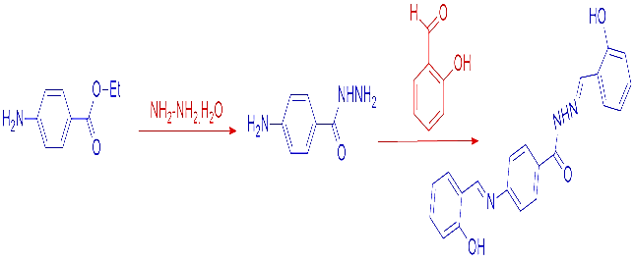
Scheme 1. Synthesis of Schiff base.
When PVC was reacted with the Schiff base in tetrahydrofuran (THF), it predominantly yielded the corresponding modified PVC with a high degree of transformation (Scheme 2).
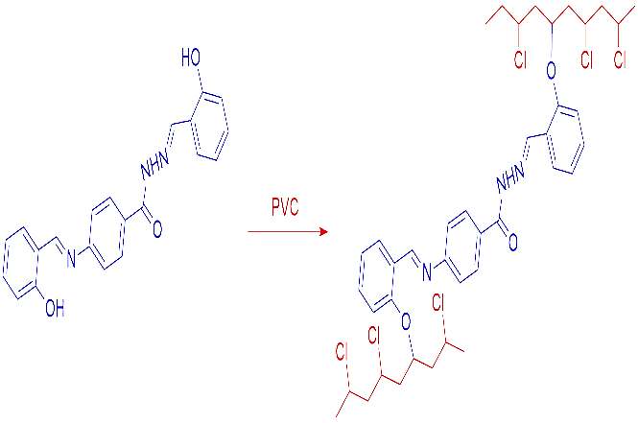
Scheme 2. Synthesis of modified PVC.
Table 1. Physical properties of synthesized compounds.
Compound | Color | Yield % | M.P. °C
I | White | 96% | 225-227
II | Orange | 94% | 215-217
III | Orange | 77% | 207-209

Fourier transform infrared spectroscopy
The FTIR spectrum of 4-aminobenzohydrazide (compound I) illustrates notable changes: the absorption band of the carbonyl group (C=O) shifts due to the conversion of the compound from an ester to an amide, and the aliphatic C-H signals disappear. The spectrum displays vibrations at 3295 cm⁻¹ and 3190 cm⁻¹ for the asymmetrical and symmetrical NH₂ vibrational bands, 3150 cm⁻¹ for NH, 3005 cm⁻¹ for aromatic C-H, and a newly appearing stretching band at 1658 cm⁻¹ corresponding to the carbonyl amide group. Compound II's spectrum exhibits a band at 3248 cm⁻¹ signifying the o-position hydroxyl group, 3073 cm⁻¹ for aromatic C-H, and 2910 cm⁻¹ and 2851 cm⁻¹ for aliphatic C-H, along with a notable signal at 1653 cm⁻¹ for C=O. Additionally, there is an overlapping band at 1606 cm⁻¹ representing C=N, alongside the absence of both asymmetric and symmetric NH₂ signals. The FTIR spectrum of compound III reveals the emergence of broad bands indicative of the polymer's presence. Notably, the absorption band of the hydroxyl group (OH) vanishes, while new bands appear at 3242 cm⁻¹ for NH, 3070 cm⁻¹ for aromatic C-H, an overlapping signal at 2912 cm⁻¹ for aliphatic C-H, a distinct C-O-C signal at 1320 cm⁻¹, and a pronounced band at 684 cm⁻¹ indicating the presence of C-Cl.
The FTIR spectra reveal stretching and bending vibration bands that provide insights into the distinctive chemical composition of PVC (blank) and modified PVC films following exposure to various temperatures (25, 50, and 100 °C). The intensity of peak bands is influenced by temperature variations (as depicted in Fig. 1 and summarized in Table 2). The examination of PVC chain interaction and alterations induced by the thermal stabilizer involved investigating characteristic bands in the FTIR spectra of PVC. Notably, the FTIR spectra of PVC films displayed bands situated around 1722 cm⁻¹, corresponding to C=O groups [21-23]. Figure 1 illustrates the FTIR spectra recorded from unmodified PVC samples subjected to oven aging. The peak at 1722 cm⁻¹ was attributed to C=O (carbonyl) vibrations. During the course of oven aging, the intensity of this peak escalated, culminating in the highest value observed.
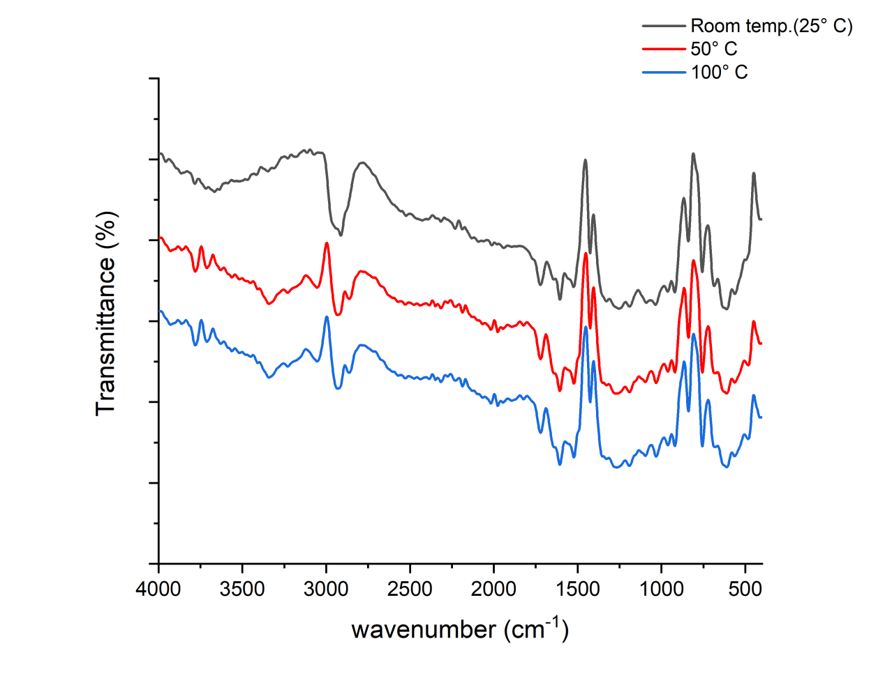
Fig. 1. FT-IR spectra of modified PVC film during exposure to different temperatures.
Table 2. FT-IR spectral data for modified PVC.
Temp. °C | C=O | C=N | C=C | C-Cl
25 | 1721 | 1605 | 1523 | 839
50 | 1721 | 1605 | 1520 | 837
100 | 1721 | 1605 | 1520 | 837

The functional group Index
The functional group index (I_{s}) is determined by the absorbance peak during the analysis (A_{s}) and the reference peak (A_{r}), as outlined in Equation (1) [24]:
I_{s} = A_{s}/A_{r} … (1)

The carbonyl index (I_{C=O}) of the films was computed at various temperatures and is illustrated in Figure 2. Calculations of functional group index and the assessment of the degradation-induced alterations were performed in a single instance for each PVC film. Notably, the blank PVC film exhibited more substantial variations in functional index values compared to the modified PVC film. These findings provide confirmation of the effective role of the Schiff base as thermal stabilizer for PVC.

Fig. 2. Changes in the I_{C=O} upon exposure to different temperatures.

Weight loss
The dehydrochlorination process in PVC polymer takes place at elevated temperatures, resulting in the removal of hydrogen chloride and subsequent material loss [25]. This process also generates noxious volatile pollutants and causes discoloration of the polymer. The employment of Schiff base demonstrates its potential to alter and enhance PVC's stability against degradation caused by oven aging. During this experiment, PVC films were subjected to heating, and the weight loss (%) was computed [26], where W₀ signifies the initial weight of the film, and W_{t} is the weight subsequent to heat exposure.
Weight loss (%) = [(W₀ − W_{t})/W₀] × 100 … (2)
Figure 3 illustrates the fluctuations in weight loss (%) of PVC films under different temperature conditions. Importantly, the weight loss observed in the blank PVC film was higher compared to that of the modified PVC. Among the samples examined, the modified PVC demonstrated the lowest weight loss, indicative of its enhanced resistance to degradation.

Fig. 3. Changes in mass loss (%) upon exposure to different temperatures.
Morphology of Plain and Modified PVC Films
To assess the color durability of PVC specimens, a technique involving aging in an oven was employed, and the resulting alterations were monitored using optical microscopy [27]. The aging procedure demonstrated differing rates of change, influenced by the structural characteristics of the films. Consequently, noticeable changes in film hues were observed due to the process of dehydrochlorination and the formation of connected double bonds within the PVC samples. The influence of temperature on the surface structure of both PVC and PVC films was investigated as temperatures were elevated from around 25 to 100 °C, utilizing an optical microscope with a resolution of 400X. As illustrated in Figure 4, the altered PVC surface exhibited consistent stability even when subjected to temperatures spanning from 25 to 100 °C.
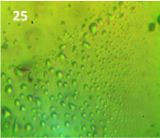 |  | 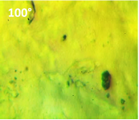
Fig. 4. Optical microscope images for modified PVC at 25, 50 and 100 °C).

AFM test
The utilization of the AFM instrument was carried out to explore how thermal conditions affect surface structure. This involved the analysis of two-dimensional (2D) and three-dimensional (3D) surface images, surface roughness measurements, and particle size assessment [28]. The AFM has demonstrated its utility in studying the uneven and rugged surfaces of polymers subjected to radiation. The impacts of rising temperatures on the surface roughness characteristics and particle size of both untreated PVC and modified PVC films are presented in Table 2. In Figure 5, both untreated PVC and modified PVC film surfaces display an increase in roughness as the thermal temperature is raised. These observations indicate a significant reduction in the rates of dehydrochlorination and bond disruption, lending support to the findings of this investigation.
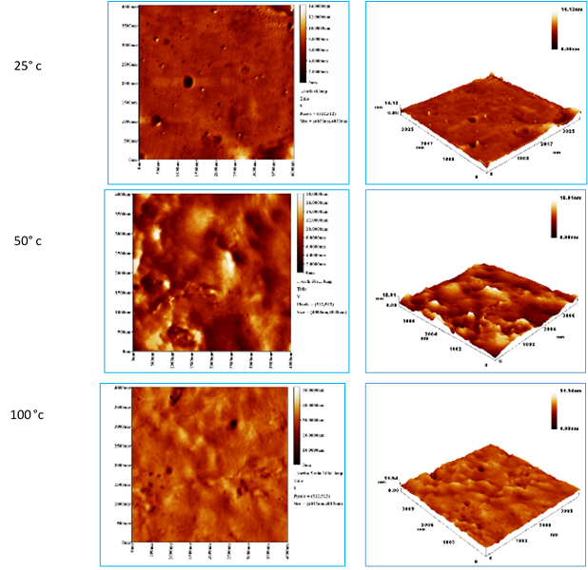
Fig. 5. AFM images for PVC and modified PVC at 25, 50 and 100 °C
Table 2. Surface properties analysis for modified PVC.
Temp. °C | Roughness Average (nm) | Particle size (nm)
25 | 55.02 | 0.61
50 | 173.04 | 1.76
100 | 149.77 | 2.38

Comparatively, the average particle roughness of pure PVC increased with rising temperature when compared to its average roughness at room temperature, implying a slight divergence in the polymer's structure [29]. Conversely, the average surface roughness of modified PVC was less sensitive to temperature changes compared to blank PVC.
The evaluation of color stability through oven aging of PVC films was performed using optical microscopy, as depicted in Fig. 6. Based on the information presented in the table, the process of aging manifested itself at different rates, influenced by the specific structural attributes of the films. As a result, modifications in the colors of the films were detected, which can be attributed to the process of dehydrochlorination and the appearance of connected double bonds within the PVC samples. It's worth noting that untreated PVC experienced rapid changes during the aging process, leading to a blackened appearance. In contrast, the modified PVC films exhibited an improved ability to maintain their thermal and color integrity, showcasing increased resistance to discoloration. Additionally, Figure 6 offers detailed, high-resolution images of the modified PVC films captured at rising temperatures, further serving as evidence of the thermal influence on the film's surface [30]. Notably, the modified PVC film reached a critical point while maintaining its original color.
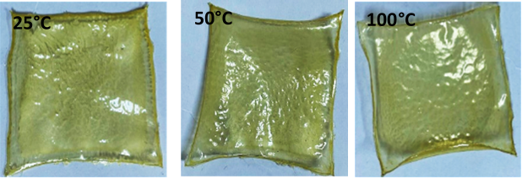
Fig. 6. Modified PVC images after exposure to heat at different temperatures.

Conclusions
Modified PVC was prepared with the objective of augmenting the polymer's thermal stability and preventing thermal degradation. Through the implementation of an oven-aging test, enhancements were observed in terms of the initial color retention and the time taken for blackening of the PVC films. The investigation encompassed a range of characterization methods, including analyzing specific functional groups in the infrared spectra, quantifying weight loss, and assessing surface morphology using both optical microscopy and atomic force microscopy. The results illustrated a prolonged period before the color change occurred. Overall, the modified PVC exhibited a remarkable enhancement in thermal stability. This improvement could be attributed to the Schiff base's potent HCl neutralization capability and its effectiveness in passivating labile chlorine atoms within the polymer chains. These modifications collectively contributed to the extended onset of thermal degradation and color changes, validating the efficacy of the modification approach in enhancing the thermal stability of PVC.
Funding Sources
None.
Acknowledgment
The authors like to express their thanks to Al-Nahrain University for partially supporting this work.
References
[1] . Gopanna, A., Thomas, S.P., & Rajan, K.P. (2021). Effect of hot climate of Saudi Arabia on physical and mechanical properties of single use polypropylene packaging films. Yanbu J. Eng. Sci., 18, 65–75.
[2]. Khalid, M.Y., Arif, Z.U., Noroozi, R., Zolfagharian, A., & Bodaghi, M. (2022). 4D printing of shape memory polymer composites: A review on fabrication techniques, applications, and future perspectives. J. Manuf. Process., 81, 759–797.
[3]. Fu, S., Sun, Z., Huang, P., Li, Y., & Hu, N. (2019). Some basic aspects of polymer nanocomposites: A critical review. Nano Mater. Sci., 1(1), 2–30.
[4]. Gao, Y., Qiu, L., O’Hare, D., & Wang, Q. (2020). Thermal properties and flame-retardant characteristics of layered double hydroxide polymer nanocomposites. In Layered Double Hydroxide Polymer Nanocomposites, 311–345.
[5]. Braun, V.D., Thallnaier, M. (1966). Zum mechanismus der thermischen chlorwassmtoffabspaltung aus polyvinylchlorid. 3. Mitt. Über die lange der poly- € ensequenzen in partiell dehydrohalogenierten poiyvinylchloriden, polyvinylbromiden und vinylchlorid-copolymeren. Makromol. Chem., 99(1966), 59e75. https://doi.org/10.1002/macp.1966.020990106.
[6]. Wakeman, I.B., & Johnson, H.R. (1978). Vinyl chloride formation from the thermal degradation of poly(vinyl chloride). Polym. Eng. Sci., 18(1978), 404e407. https://doi.org/10.1002/pen.760180512.
[7]. Wimberley, J.W., Carel, A.B., & Cabbiness, D.K. (1982). Conoco Inc., automated method for measuring the thermal degradation of polyvinyl chloride. Anal. Lett., 15(1982), 89e100. https://doi.org/10.1080/00032718208064366.
[8]. Risby, T.H., Yergey, J.A., & Scocca, J.J. (1982). Linear programmed thermal degradation mass spectrometry of polystyrene and poly(vinyl chloride). Anal. Chem., 54(1982), 2228e2233. https://doi.org/10.1021/ac00250a022.
[9]. Anders, H., & Zimmermann, H. (1987). A comparison of the thermal degradation behaviours of poly(vinyl acetate), poly(vinyl alcohol) and poly(vinyl chloride). Polym. Degrad. Stabil., 18(1987), 111e122. https://doi.org/10.1016/0141-3910(87)90024-3.
[10]. Lakshmi, S., & Jayakrishnan, A. (1998). Polymer, 39, 151-157.
[11]. Kameda, T., Grause, G., & Yoshioka, T. (2010). Mater. Chem. Phys., 124, 163-167.
[12]. Liu, C., Luo, Y., Zhong, B., Li, S., Guo, B., & Jia, D. (2011). Express Polym. Lett., 5, 591-603.
[13]. Zou, Y., Kizhakkedathu, J., & Brooks, D. (2009). Macromolecules, 42, 3258-3268.
[14]. Milenkovic, J., Hrenovic, J., Goic-Barisic, I., Tomic, M., Djonlagic, J., & Rajic, N. (2014). Biofouling, 30, 965-973.
[15]. Ghoranneviss, M., Shahidi, S., & Wiener, J. (2010). Plasma Sci. Technol., 12, 204-207.
[16]. Haishima, Y., Isama, K., Hasegawa, C., Yuba, T., & Matsuoka, A. (2013). J. Biomed. Mater. Res. A, 101, 2630-2643.
[17]. Kameda, T., Ono, M., Grause, G., Mizoguchi, T., & Yoshioka, T. (2009). Polym. Degrad. Stabil., 94, 107-112.
[18]. Reyes-Labarta, J., Herrero, M., Tiemblo, P., Mijangos, C., & Reinecke, H. (2003). Polymer, 44, 2263-2269.
[19]. Sacristán, J., Reinecke, H., & Mijangos, C. (2000). Polymer, 41, 5577-5582.
[20]. McCoy, C., Cowley, J., Gorman, S., Andrews, G., & Jones, D. (2009). J. Pharm. Pharmacol., 61, 1163-1169.
[21]. Ahmed, D.S., Kadhom, M., Hadi, A.G., Bufaroosha, M., Salih, N., Al-Dahhan, W.H., & Yousif, E. (2021). Tetra Schiff Bases as Polyvinyl Chloride Thermal Stabilizers. Chemistry, 3, 288-295. https://doi.org/10.3390/chemistry3010021.
[22]. Yousif, E., Abdallh, M., Hashim, H., Ahmed, A., Ahmed, D. S., Yusop, R. M., & Ahmed, A. A. (2019). Enhancement of the photo-chemical properties and efficacy of the mixing technique in the preparation of Schiff base-Cu (II)/poly (vinyl chloride) compounds. Emergent Materials, 2, 505-512.
[23].Yousif, E., & Ahmed, D. S. (2019). Poly (vinyl chloride) reinforced Schiff base as an eco-friendly alternative to conventional PVC. SN Applied Sciences, 1(9), 955.
[24]. Sansul, S., Yousif, E., Ahmed, D.S., El-Hiti, G.A., Kariuki, B.M., Hashim, H., & Ahmed, A. (2023). Pendant Modification of Poly(methyl methacrylate) to Enhance Its Stability against Photoirradiation. Polymers, 15, 2989. https://doi.org/10.3390/polym15142989.
[25]. Arraq, R.R., Hadi, A.G., Ahmed, D.S., El-Hiti, G.A., Kariuki, B.M., Husain, A.A., Bufaroosha, M., & Yousif, E. (2023). Enhancement of Photostabilization of Poly(Vinyl Chloride) in the Presence of Tin–Cephalexin Complexes. Polymers, 15, 550. https://doi.org/10.3390/polym15030550.
[26]. Mousa, O.G., El‐Hiti, G.A., Baashen, M.A., Bufaroosha, M., Ahmed, A., Ahmed, A.A., Ahmed, D.S., & Yousif, E. (2021). Synthesis of Carvedilol–Organotin Complexes and Their Effects on Reducing Photodegradation of Poly(Vinyl Chloride). Polymers, 13, 500. https://doi.org/10.3390/polym13040500.
[27]. Ahmed, A., Abdallh, M., Al-Mashhadani, M. H., Ahmed, D. S., Bufaroosha, M., Jawad, A. H., & Yousif, E. (2021). Environmental stability of poly (vinyl chloride) modified by schiff’s base under exposure to UV. Biointerface Research in Applied Chemistry, 11(5), 13465-13473.
[28]. Yaseen, A. A., Yousif, E., Al-Tikrity, E. T., El-Hiti, G. A., Kariuki, B. M., Ahmed, D. S., & Bufaroosha, M. (2021). FTIR, weight, and surface morphology of poly (vinyl chloride) doped with tin complexes containing aromatic and heterocyclic moieties. Polymers, 13(19), 3264.
[29]. Yousif, E., Asaad, N., Ahmed, D. S., Mohammed, S. A., & Jawad, A. H. (2019). A spectral, optical, microscopic study, synthesis and characterization of PVC films containing Schiff base complexes. Baghdad Science Journal, 16(1).
[30]. Majeed, A., Yousif, E., El‐Hiti, G. A., Ahmed, D. S., & Ahmed, A. A. (2020). Stabilization of Poly (vinyl chloride) containing captopril tin complexes against degradation upon exposure to ultraviolet light. Journal of Vinyl and Additive Technology, 26(4), 601-612.

تحوير بولي فينيل كلورايد بوساطة جزيء عضوي لتحسين ثباتيته الحرارية
زهراء عدنان¹، أحمد أحمد¹، دينا أحمد²، الاء رشاد¹، محمد كاظم³، أمعمر رضوان⁴، وليد أحمد⁵، عماد يوسف^{1،*}
¹ قسم الكيمياء، كلية العلوم، جامعة النهرين، بغداد، العراق
² قسم الصناعات الكيمياوية، معهد تكنولوجيا-بغداد، الجامعة التقنية الوسطى، بغداد، العراق
³ قسم علوم البيئة، كلية الطاقة وعلوم البيئة، جامعة الكرخ للعلوم، بغداد، العراق
⁴ قسم الكيمياء، كلية العلوم، جامعة بني الوليد، بني وليد، ليبيا
⁵ قسم الكيمياء، كلية التربية، جامعة ذمار، ذمار، اليمن
Email: emadyousif@hotmail.com

الخلاصة:
أصبح تحسين استقرار PVC مهمة للعديد من المجموعات البحثية لتحسين خصائصه وتقليل التلوث البلاستيكي. تم استخدام قاعدة شيف المحضرة كعامل مقاوم للحرارة لتغيير سلوك كلوريد البولي فينيل (PVC) تحت درجات حرارة متفاوتة. تم تقييم فعالية اغشية PVC المعالجة بقاعدة شيف من حيث الثبات الحراري من خلال تحليل فقدان الوزن، ومطيافية الأشعة تحت الحمراء (FTIR)، والمجهر البصري، ومجهر القوة الذرية (AFM). أظهرت النتائج أن دمج الـ PVC المحور أدى إلى إطالة مدة ثبات البوليمر، وبالتالي خفض ميله نحو التحلل. علاوة على ذلك، أدت قاعدة شيف إلى انخفاض ملحوظ في وجود الروابط المزدوجة المترافقة من PVC، وبالتالي تقليل فقدان الوزن. يمكن أن يُعزى التعزيز الملحوظ إلى قدرة قاعدة شيف القوية على تحييد حامض الهيدروكلوريك وفعاليته في حماية ذرات الكلور غير المستقرة داخل سلاسل البوليمر. أدت هذه التعديلات، عند دمجها، إلى تأخير طويل في التدهور الحراري وتغييرات في اللون، مما يؤكد نجاح طريقة التعديل في تحسين الثبات الحراري للـ PVC.
الكلمات المفتاحية: بولي فينيل كلورايد (PVC); مورفولوجيا السطح; الاستقرار الحراري; تحوير; قاعدة شيف

