|  |  |  |
| --- | --- | --- |
| D:\مجلة\last\شعار المجلة.jpg**Microfacies analysis and depositional environment of Euphrates Formation (Lower Miocene) at Al-Baghdadi Area, western Iraq**  **Sufyan Shlash Hamadi Alrawi1*, Abdulhameed Al-Hadaithy2 and Lafta Salman Kadhim3**  1,3Department of Geology, College of Science , University of Tikrit;  2Department of Applied Geology, College of Science, University of Anbar, Iraq | | |
| **ARTICLE INFO** | |  | **ABSTRACT** | |
| Received: 04 / 05 /2023  Accepted: 22 / 05/ 2023  Available online: 06 / 06 / 2023   |  | | --- | | DOI: 10.37652/juaps.000000 | | |  | The current study including microfacies analysis and depositional environment aspects of (10) rock samples from Euphrates Formation in outcrop location is at Al-Baghdadi city, with a thickness of this formation 19 meters, It is consists of gray, hard, porous, weathered, Peloidal, and dolomitic limestone. The layer of basal Conglomerate with a thickness of about 6 meters in the study outcrop, which consists of calcareous Conglomerate of different sizes, indicates a stratigraphic unconformity, which is the contact between the Miocene and Oligocene formations. The age of this formation is lower Miocene. The formation within this section is rich in benthic foraminifera and other types of fossils such as *corals*, *echinoderms*, and *pelecypoda*. In this study, determine three main types of microfacies were distinguished in this Formation, namely: peloidal lime grainstone, lime wackstone, dolostone. By studying the microfacies types and abundance of benthic foraminifera and other species, the depositional environment of Euphrates Formation was deduced, which represents a restricted marine. | |
| **Keywords:**  **Euphrates,**  **outcrop,** **Microfacies**  **Environment, Grainstone**  **Dolostone***,*  Copyright©Authors, 2023, College of Sciences, University of Anbar. This is an open-access article under the CC BY 4.0 license ([http://creativecommons.org/licens es/by/4.0/](http://creativecommons.org/licens%20es/by/4.0/)). | |  |

**INTRODUCTION**

The Euphrates Formation appears widely within the Upper Euphrates Valley, where it passes through the cities of Al-Qaim, Haditha, and Al-Baghdadi, within the eastern edge of the Euphrates River. The study area is located in the northern part of the Anbar Governorate about 90 km from Ramadi city, with coordinates longitudinal (42° 31' 46") E and Latitudinal ( 33° 51' 36" ) N (fig-1).The Euphrates Formation consists of basal conglomerates bed with a thickness of about six meters, it turn towards the top into marlly limestone by 2 meter, and in it is upper parts into dolomitic limestone. The aim of this study is distinguished the microfacies types depending on the abundance fossils, and then find the depositional environment for the formation, which was represented by a restricted marine. There are many previous studied with different aims, and these studies are: [1]

*Corresponding author at: Department of Applied Geology ,College of Science , University of Tikrit;

ORCID:https://orcid.org/0000- ;Tel:+9647714997150

[E-mail](mailto:Sulaf.mohammed@univsul.edu.iq) address:[**sufyanalrawi1@gmail.com**](mailto:sufyanalrawi1@gmail.com)

He studied the mineralogical and geochemical for Euphrates Formation and it was deposited in open to restricted platforms which indicated lagoonal environment with warm and restricted open circulation, [2] He studied the depositional environment and the sequence stratigraphy of the Euphrates formation in Haditha, and concluded that the slow deposition is caused by the change in sea level, [13] He studied the microfacies analysis and sedimentary model of the Ajil oil field and divided the formation into three depositional environments (shallow, slope and lagoon). [16] He studied the depositional environment of the Euphrates formation and stated that the environment of the Euphrates formation is divided into three environments (evaporites, Restricted and open sea), [6], [14].

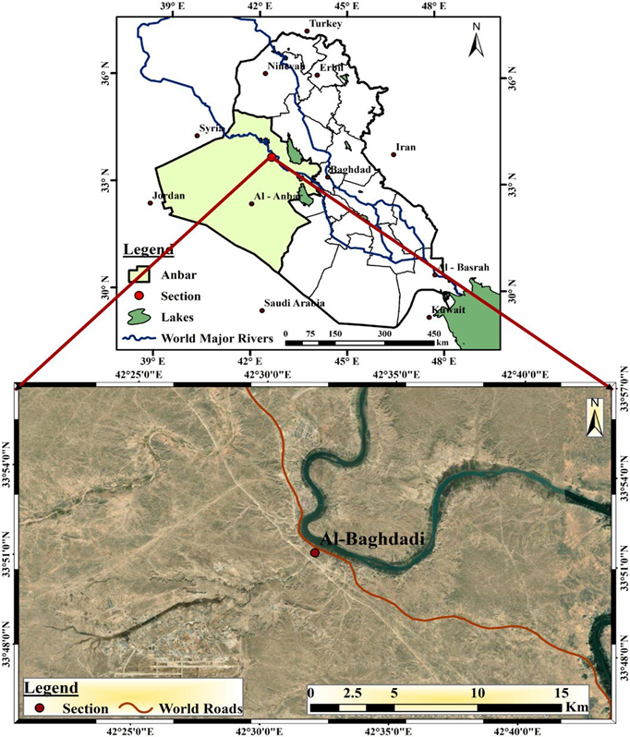

**Fig.1 Location map of study area.**

**Geological setting**

The Al-Baghdadi section is located in the northeastern part of the Arabian plate. The current study is within the main tectonic division, which is the Stable shelf of western Iraq [12]. This study area is bounded from the north by the Jazera subzone, from the east by the Salman Zone, and from the west by Syria and Jordan (fig-2). The section is also bounded by two types of transverse faults zone, which are Sirwan faults zone from the south, and Anah Qalat Dhiza faults zone from the north within central Iraqi block [12]. Euphrates and Abu-Jir faults zone are a main structural in the northern and eastern parts of this area, and these faults zone formed the boundary between the stable shelf and unstable shelf of Arabian platform.

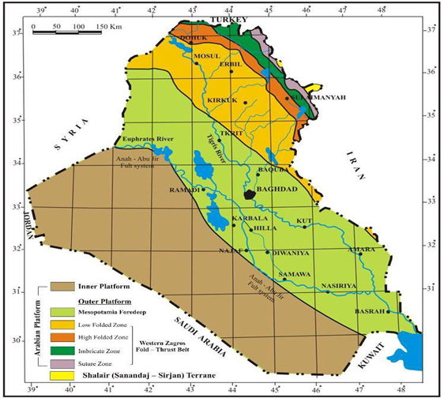

**Fig.2 tectonic map of Iraq [7]**

**Sampling and Methodology**

Field work was carried out on Al-Baghdadi section (fig-3), and the required measurements were taken, in addition to taking 8 samples on the basis of physical properties, including color, hardness, and size of particle. Lab work: 8 thin sections were made from each rock sample for later study, to determine the types of microfacies, and then to devise the depositional environment for the formation under study. All thin sections are prepared and examined under the binocular microscope.

**Microfacies**

Microfacies are defined as a group of bio and sedimentary characteristics that can be classified and distinguished by studying thin sections [10]. The main objective of the study of microfacies is to identify the major and minor facies of the rock units within the Formation, depending on their characteristics.

1. **Peloidal Lime Grainstone Microfacies:** This facies is dominated in lower parts of Euphrates Formation, with about five meters thick. It is consists of peloids (85%) and oolites (5%). This facies is usually formed in subtidal and intertidal shallow- water setting and low-energy watar, by 30 meters water depth [8]. The peloidal found in this facies her are elliptical, rounded form and it is lost her central part due solution processes. The facies is similar to the Standard facies assumed by [15] SMF.18, which located within FZ.7,8 facies Zone Plat.1 A. This facies was deposited in restricted environment.

**2- Miliolids Lime wackstone Microfacies**: The facies was distinguished in lower parts of Euphrates Formation, with three meters thick. This facies is consists of miliolids about (20%) and (80%) micrite. The appearence of imperforate foraminifera as miliolids may indicate a depositional setting that is slightly saIin [9]. The miliolids are commonly present in lagoon/ back-reef setting [9]. This facies is similar to SMF.10 and FZ.7 facies zone Plat.1 D,C. The facies is described to be associated with lagoonal of an inner ramp setting. This microfacies is deposited in open marine environment.

**3- Dolostone Microfacies:** This facies appear in the middle and upper parts of the Euphrates Formation, with a thickness of more than ten meters. The dolostone facies consists mainly of dolomite about (90%).This facies appear to be affected by processes, especially in the dolomitized process, This dolomite is formed as a result of diagnosis processes after sedimentation, and the rhombic dolomite crystals appear clearly. This facies to equivalent of SMF.21 and FZ.8,9 Facies Zone Plat.1 E,F[17]. The facies was deposited in the restricted environment.

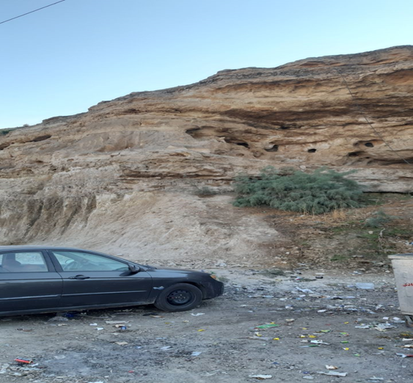

**Fig.3 Field work of Al-Baghdadi section.**

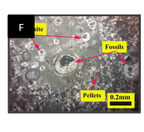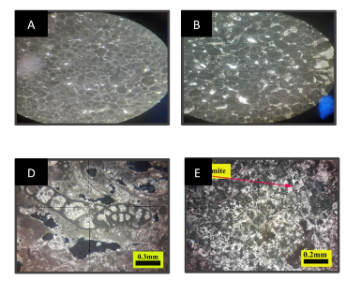

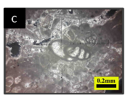

**Plat.1 A. Peloidal lime grainstone, B. oolitic lime packstone, C and D. miliolids lime wackstone, E and F. dolostone.**

**Depositional environment**

The main Carbonate system in marine environment of Euphrates Formation lower Miocene are defined and represented by lagoon/restricted, and open marine environment. The facies of Euphrates Formation in this section represent peloidal lime grainstone, miliolids wackstone, and dolostone (fig-4). The peloidal lime grainstone facies is an indication of a deposition in restricted environments, and it is indicator on low-energy and shallow water depth about 30 meters. The miliolids lime wackstone deposited in open marine environment. Dolostone facies which characterized the middle and upper parts of Euphrates Formation, The appearance of dolostone facies in the middle and upper parts is further evidence that the marine environment was confined, and it is affected by diagnosis processes as dolomite and solution but in different proportions, The layer of basal Conglomerate with a thickness of about 6 meters in the study outcrop, which consists of calcareous Conglomerate of different sizes, indicates a stratigraphic unconformity, which is the boundary between the Miocene and Oligocene formations.

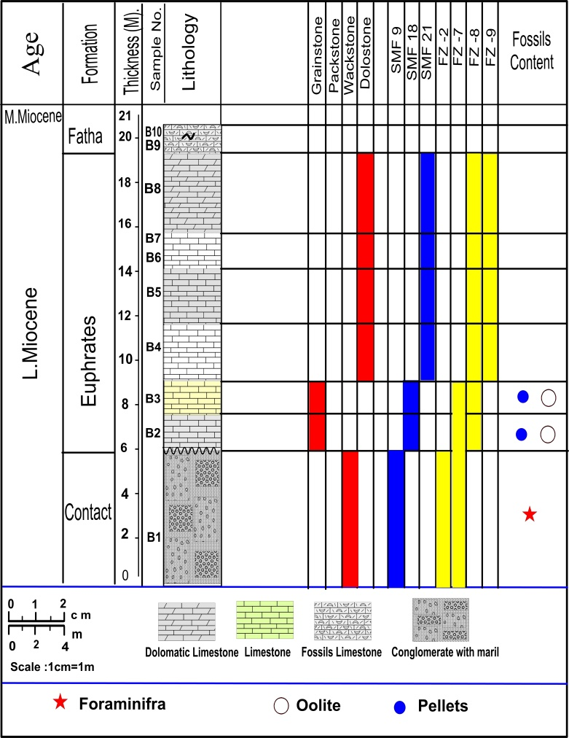

**Fig.4 Vertical facies distribution of the Euphrates Formation.**

**Conclusions**

The Euphrates Formation is exposed in Al-Baghdadi section within the Upper Euphrates Valley, with 19 meters thick. It consists of gray, hard, weathered, Peloidal, porous, and dolomitic limestone. The upper contact of this Formation is Fatha Formation of Middle Miocene, while the lower contact is Sheik Alas Formation of Lower Oligocene [3]. The layer of basal Conglomerate with a thickness of about 6 meters in the study outcrop, which consists of calcareous Conglomerate of different sizes, indicates a stratigraphic unconformity, which is the boundary between the Miocene and Oligocene formations. Evidence of the presence of ( *Miliolids*) that reflect the warm shallow environment. Three microfacies have been identified within Euphrates Formation in this section, which are peloidal lime grainstone, miliolids lime wackstone, and dolostone. The depositional environment was deduced by distinguishing the microfacies and their fossil content. The Euphrates Formation was deposited inrestricted by presents of dolostone microfacies and peloidal lime grainstone, and open marine environment by presents of miliolids lime wackstone. The age of the Euphrates Formation is lower Miocene [3].

References

1. Al-Dabbas M, Awadh S.M, Zaid A.A (2013).Mineralogy, geochemistry, and reserve estimation of the Euphrates limestone for Portland cement industry at Al-Najaf area, South Iraq. Aran J Geosci 6(2):491-503. Brandle, J.E. and Telmer, P.G. (2007). Steviol glycoside biosynthesis. Phytochemistry 68,1855–1863.
2. Al-Ghreri, M.F (2016). Benthic Foraminifera biostratigraphy of the Euphrates Formation (Early Lower Miocene– Middle Miocene) in selected sections, Western Iraq. Iraqi Journal of Science .56(1B):424-434.
3. Al-Ghrire, M.F.(2007). Biostratigraphic succession of the formation of Euphrates valley between Hit and Al-Qayim in Iraq , PhD thesis, University of Baghdad, Iraq. 121 p.
4. Al-Mutwali M. M., and Al-Rubai H. A. (2021). Geological history , Ichnofacies and Sequence Stratigraphy of the Eocene – Oligocene Boundary at Sinjar Area , Northwestern Iraq . Iraqi National Journal of Earth Sciences 21 (1) :27 – 45.
5. Al-Nuaimy Q. A. M.(2018) :Morphometric analysis of chattian- Early Aquitanian Miogypsinidae from Iraq and their stratigraphic distribution in the Arabian Tethys . Arabian Journal of Geosciences 10:542, 2-17.
6. Ameen F. A. , Fattah A. I. , and Qader B. O. (2020). Microfacies and depositional environment of Upper Oligocene and lower Miocene successions from Iraqi Kurdistan Region . Kuwait Journal of Sciences. 47 (4).
7. Fouad, S.F. (2015) '' Western Zagros fold-thrust belt, part II: the high folded zone'', Iraqi Bulletin of Geology and Mining (6): 53-71.
8. Geel , T. (2000). Recognition of stratigraphic sequences in carbonate platform and slope deposies : empirical models based on microfacies analysis of Palaeogene deposits in southeastern Spain, Palaeogeography ,Palaeoclimatology, Palaeoecology 155: 211-238.
9. Ghosh , A. M. (2002) . Cenozoic coralline algal assemblage from southwestern kutch and its importance in palaeoenvironment and palaeobathymetry. Current science, Vol. 83 , No.2 ,pp.153-158.
10. Flugel, E. (1982). Microfacies analysis of limestones. Translated by K. Christenson . springer , Berlin , 633 p.
11. Flugel, E. (2010). Microfacies of carbonate rocks: analysis, interpretation and application, 2nd ed. Springer , Berlin 929 p.
12. Jassim ,S. Z. ,and Goff , J.C. (2006). Geology of Iraq. Dolin and Moravian museum , prague , 341.
13. Mahammed, M. H. , and Nasser , M. E. (2018). Facies Analysis and Geological Modelling of Euphrates formation in Ajeel Oil Field , Northern Iraq. Iraqi Journal of Science :2065-2079.
14. Qader, F. M. , and Ali, S. M.(2022) Reservoir Characteristics of the Lower Miocene Carbonate Formation in Kor Mor Gasfield, Kirkuk Area, NE Iraq. Tikrit Journal of Pure Science, 27(3): 43-52.
15. Wilson , J. L. (1975). Carbonate facies in Geological history. Springer, NewYork , 471 p.
16. Lazam, S.A. (2019): Petrography Study of the Euphrates Formation (Early Miocene) in Muthanna Area, Southern Desert, Iraq. Indian Journal of Natural Sciences. Vol.9 /Issue 52.
17. Sadi Kan Jan, (2009) : Microfacies Study of Hadiene formation (North Iraq). Iraq Natural History Museum, University of Baghdad, Bab Al-Muadham, Baghdad. (2009)Vol.10No.(4):pp 49-58.

**التحليل السحني والبيئة الرسوبية لتكوين الفرات (المايوسين الاسفل) في منطقة البغدادي، غرب العراق**

**سفيان شلاش حمادي الراوي، عبدالحميد عبد الحديثي، لفته سلمان كاظم**

1, 3قسم علوم الارض التطبيقية , كلية العلوم ,جامعة تكريت

2قسم علوم الارض التطبيقية, كلية العلوم ,جامعة الانبار

**Email;** [**sufyanalrawi1@gmail.com**](mailto:sufyanalrawi1@gmail.com)

**الخلاصة :**

تشمل الدراسة الحالية تحليل السحنات الدقيقة وجوانب البيئة الترسيبية لـ (10) عينات صخرية من تكوين الفرات في مكشف الدراسة الذي يقع في مدينة البغدادي ، ويبلغ سمك هذا التكوين 19 مترا ، ويتكون من الحجر الجيري الرمادي ، الصلب ، المسامي ، المجوي ، الحبيبي ، والدولوميت. طبقة المدملكات القاعدية سمكها حوالي 6 أمتار في مكشف الدراسة ، والتي تتكون من مدملكات جيرية بأحجام مختلفة ومارل ، تشير إلى عدم توافق طبقي ، وهو الحد الفاصل بين تكوينات الميوسين والأوليكوسين. عمر هذا التكوين هو الميوسين الاسفل. التكوين غني بالمنخربات القاعية وأنواع أخرى من الحفريات مثل الشعاب المرجانية وشوكيات الجلد والبليسيبودا. في هذه الدراسة ، تم تحديد ثلاثة أنواع رئيسية من السحنات الدقيقة في هذا التكوين ، وهي: سحنة الحجر الجيري الحبيبي ، سحنة الحجر الجيري الطيني ، سحنة الدولوستون. من خلال دراسة أنواع الكائنات الدقيقة ووفرة المنخربات القاعية والأنواع الأخرى ، تم استنتاج البيئة الترسيبية لتكوين الفرات ، والتي تمثل بيئة بحرية مقيدة.

**الكلمات المفتاحية**: الفرات, *مكشف*, السحنات الدقيقة ، الحبيبي.